Warning – Check Locking Differential (Elocker) – CGEA1.3

Functional Description

The purpose of the Check Locking Differential (Elocker) Warning is to inform the driver of a malfunction with the Electronic Locking Differential.

The Check Locking Differential (Elocker) Warning correlates the LsdSrvcRqd_B_Rq signal and the Operational _Mode to determine when to display the Check Locking Differential Warning.

Interfaces

Interface Context Diagram (I/O Block Diagram)

- Check Locking Differential (Elocker) Warning Context Diagram

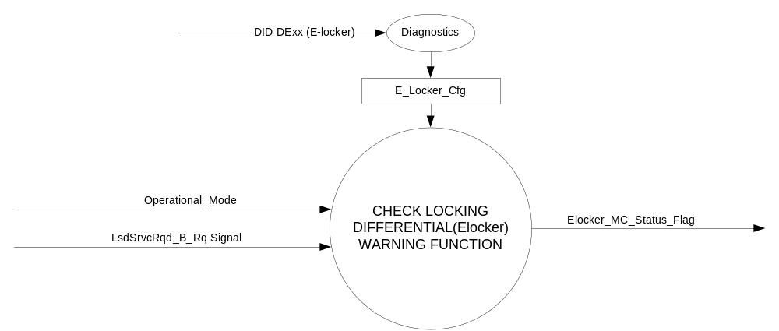

Inputs
      - INTERNAL:
    - Operational_Mode
    - E_Locker_Cfg
- MUX message on the CAN Bus from the TCCM

- AwdSrvcRqd_B_Rq Signal
Signal Name | Size (bits) | Detail | Units | Res. | Offset | State Encoded | Min | Max
LsdSrvcRqd_B_Rq | 1 |  | SED | 1 | 0 |  | 0 (0x0) | 1 (0x1)
 |  | Off |  |  |  | 0x0
 |  | On |  |  |  | 0x1

Output
Elocker_MC_Status_Flag

Function/Performance

Operational Modes

Mode | Differentiating Vehicle Conditions
Sleep Mode | Elocker_MC_Status_Flag = Inactive
Limited Mode | Elocker_MC_Status_Flag = Inactive
Normal Mode | Elocker_MC_Status_Flag = Inactive/Active
Crank Mode | Elocker_MC_Status_Flag = Inactive/Active

The above table references the setting of the Warning flag as per this section. However, the actual warning display operational modes are displayed in the Message Center section of this SPSS.

Voltage Levels

Refer to the Cluster Features Table located in the Operational Modes and Voltage Range Strategies Section of this SPSS.

Human-Machine Interface

Visual

Indicator Graphics / Display Format
Message Center Text Warning Message as defined in section 1.3.5.7 of this document.

1.3.3.1.2 Indicator Color Coordinates

Reference section COLOR & ILLUMINATION REQUIREMENTS (GRAPHICS).

Audio

None

Switch Control Logic

None.

System Accuracy

Within 100 msec of receiving a message that results in a change of state the cluster will update the output flag to the proper state.

Operation: Performance and Functional

Subsystem Algorithm Flowchart / State Diagram

- Check Locking Differential (Elocker) Warning Configuration Flowchart

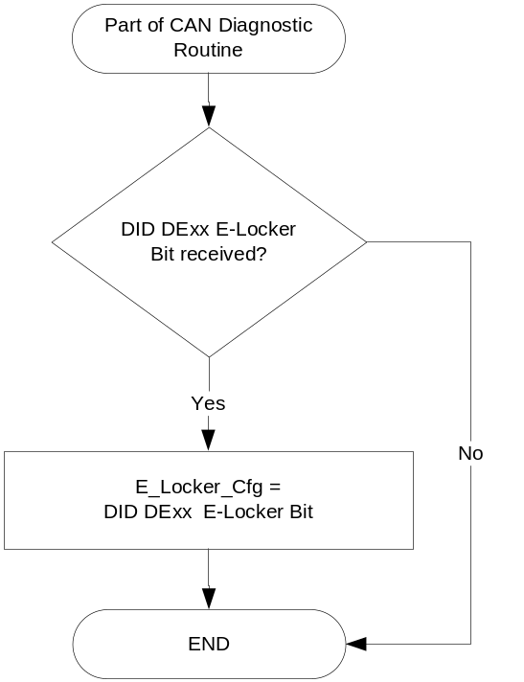

- State Matrix for Check Locking Differential (Elocker) Warning
Operational_Mode | E_Locker_Cfg | LsdSrvcRqd_B_Rq  Signal | Elocker_MC_Status_Flag
Normal or Crank | Enabled (0x1) | On (0x1) | Active
Normal | Enabled (0x1) | Missing as per 1.4.1 | Inactive
All Other Cases |  |  | Inactive

Table 1.3 Check Locking Differential (Elocker) MC Status Flag to MC Warning Message ID
Elocker_MC_Status_Flag | MC Warning Message ID | Audible
Inactive | None | None
Active | W745 (Check Locking Differential) | None

Table 1.4 System Check Function for Check Locking Differential (Elocker) Warning
Elocker_MC_Status_Flag | MC System Check Message ID | Audible
Inactive | None | None
Active | W745 (Check Locking Differential) | None

Operation Description (supports algorithm flowchart /state diagram)

- When Elocker_MC_Status_Flag = ACTIVE, Warning ID W745 will be ACTIVE.
- For definition of how the Message Center arbitrates and displays Active warnings, see the Warning / Alert Display Logic Diagram, located in the Message Center – X Display with W Button Interface section of this SPSS (where X and W are appropriate values in this document).

Function Safety Classification (EMC)

Class B

Memory Storage
Parameter Name | Description | Value at  Battery Connect | Value at  Module Wake-up
E_Locker_Cfg | Configures cluster to allow Check Locking Differential (Elocker) warning to display (set to enable at cluster end of line) | Do Not Init | Do Not Init
LsdSrvcRqd_B_Rq Signal | CAN Signal sent from the TCCM | Off (0x0) | Off (0x0)
Elocker_MC_Status_Flag | State variable used by M/C Warning Arbitrator | Inactive | Inactive
Operational_Mode | 4 state indicator for cluster operational mode | Limited | Limited or Normal or Crank

Prove Out

No.

Reconfigurable Telltale

No.

Message Center Msg

Message ID W745 as defined in the Text Message List section of this SPSS.

Error Handling

Missing Message Strategy

The signals will be declared missing as per the Diagnostics section of this SPSS.

DTCs states and history will be determined as per the Diagnostics section of this SPSS.

If E_Locker_Cfg is set to disabled, the cluster shall never log the missing message DTC due to this feature.

Diagnostics

Self Test

None

Engineering Test Mode

Not Applicable

Part II Performance

Supported Diagnostic Trouble Codes (DTCs)
DTC | Description
C10200 | Lost Communication with Transfer Case Control Module

DID DExx
Block  Num | Block Description | Byte(s) | Bits | State: Description | "0" | "1" | Default | Comments/Information
PACKETED BLOCKS
xx | Option Content (B&A) | * | * | E-locker | Disabled | Enabled | Disabled | Disabled means the feature is not present in the vehicle
 | *Byte and bit location to be identified in Part II Specification for this cluster

Supported Diagnostic Trouble Codes (DTCs)

See 1.4.1 above

Reference Specification

IS-0001 WARNINGS/INDICATORS/DISPLAYS PROVEOUT
IS-0052 OPERATING VOLTAGES - FUNCTIONAL/PERFORMANCE
IS-0069 FUNCTIONAL IMPORTANCE CLASS
IS-0324 WINDSHIELD & OTHER REFLECTIONS
IS-0327 WARNING INDICATOR EVALUATION
IS-0379 NORTH AMERICAN WARNINGS AND INDICATORS STRATEGY

IL-0017 TELLTALE AND INTERIOR ILLUMINATION – COLOR AND INTENSITY
IL-0019 GENERAL ILLUMINATION DIMMING
IL-0021 CRAFTSMANSHIP – DISPLAYS
IL-0022 GENERAL ILLUMINTATION COLOR
IL-0023 CLARITY/LEGIBILITY/READABILITY/VISUAL CONTRAST
IL -0043 OPERATIONAL ENVIRONMENT FUNCTIONALITY
IL -0045 COLOR
IL -0047 TELLTALE, INDICATOR AND DISPLAY LIGHT INTENSITY
IL -0048 ILLUMINATION ACCEPTABILITY

03-0661 PLACEMENT: CONTROL AND DISPLAY LOCATIONS
03-0662 PLACEMENT: LOGICAL GROUPING FUNCTION AND USAGE
03-0664 PLACEMENT: DOWN VISION TO COMPONENTS WITH HIGH VISUAL DEMAND
03-0665 PLACEMENT: EXPECTED LOCATIONS OF CONTROLS AND DISPLAYS VDS
03-0670 INTERIOR VISIBILITY
03-0671 INTERIOR VISIBILITY: REFLECTIONS FROM COMPONENTS & SURFACES
03-0672 INTERIOR VISIBILITY: REFLECTIONS IN DISPLAYS
03-0673 INTERIOR VISIBILITY: VISUAL OBSCURATIONS
03-0674 INTERIOR VISIBILITY: ILLUMINATION CONTROLS / DISPLAYS
03-0675 INTERIOR VISIBILITY: VEILING GLARE
03-0677 INTERIOR VISIBILITY: SUNLIGHT WASHOUT
03-0681 IDENTIFICATION: CHARACTER AND SYMBOL SIZE
03-0682 IDENTIFICATION: LEGIBILITY
03-0685 IDENTIFICATION: SYMBOLS, ABBREV FOR CONTROL
03-0721 LOGIC OF OPERATION: OPERATIONAL STEREOTYPES
03-0722 LOGIC OF OPERATION: INTERPRETATION
03-0723 LOGIC OF OPERATION: USE OF SYSTEMS WITH VISUAL DISPLAYS

Revision History

SPSS Module Revision History

Revision Level | Name | Change Description | Date
1.0 | V. Patel | Updated for CGEA 1.3 based on CGEA STSS v1.0  Section 1.2.2 – Removed table referencing the HS-CAN message that contains the input signals. | 4/12/2010
1.1 | S. Watkins  M. Hakim | Section 1.2.1, Section 1.3.5.1, and section 1.5.3:  Updated the configuration DID number from “00” to “xx” to accommodate the extended number of configuration DIDs.  Section 1.3.5.1: Figure 2:  Added Figure Title  Section 1.5.3:  Updated the default value of the E-locker Configuration from Enabled to Disabled.  Updated document footer. | 8/9/2013
2.0 | S. Watkins | System issue discovered on P552. There is a new signal defined (different from P415) that needs to be used. We need LsdSrvcRqd_B_Rq not AwdSrvcRqd_B_Rq as direction per Filip Tomik.  Steps to reproduce issue:  1) Disconnect ELD – no message appears  2) Reconnect ELD  3) Disconnect transfer case – check 4x4 and check locking differential warnings appear.  They are both triggered off of the same message which isn’t correct. When there is an issue with the t/case related hardware TCCM will set Check 4x4…Message 0x263 signal AwdSrvcRqd_B_Rq. When there is an issue with the Electronic Locking Differential TCCM will set Check Locking Differential…Message 0x4a2 signal LsdSrvcRqd_B_Rq.  Changes:  - Changed AwdSrvcRqd_B_Rq to LsdSrvcRqd_B_Rq throughout document. | 8/28/2013
2.1 | S. Watkins  M. Hakim | Updated to add DTC logging for lost communication with TCCM when the new signal LsdSrvcRqd_B_Rq is missing. | 9/24/2013

